Учреждение образования
БЕЛОРУССКИЙ ГОСУДАРСТВЕННЫЙ УНИВЕРСИТЕТ
ИНФОРМАТИКИ И РАДИОЭЛЕКТРОНИКИ

Кафедра электронных вычислительных машин

Контрольная работа
Тема: «Программная реализация пакетной передачи и алгоритма
бит-/байт стаффинга»

Выполнил:
студент группы 990541 Полховский А.Ф.

Проверил:
к.т.н., доцент ___________ Одинец Д.Н.

Минск 2022
1. Постановка задачи

В данной контрольной работе должна была решена задача программной реализации пакетной передачи (COM-порты) и алгоритма бит-/байт стаффинга.

2. Листинг

#include "com_port_communication.h"
using std::vector;
using std::string;

COM_Port_Communication::COM_Port_Communication(){
std::clog<< "COM_PORT_COMMUNICATION Obhect created"<<std::endl;
com = nullptr;
}

const std::string &COM_Port_Communication::getPort() const
{
return port;
}

void COM_Port_Communication::setPort(const std::string &newPort)
{
port = newPort;
}

unsigned long COM_Port_Communication::getBaud() const
{
return baud;
}

void COM_Port_Communication::setBaud(unsigned long newBaud)
{
baud = newBaud;
}

bool COM_Port_Communication::isOpen()
{
return com->isOpen();
}

bool COM_Port_Communication::create_com(std::string& port, unsigned long baude)
{
try {
this->com = new serial::Serial (port, baude, serial::Timeout::simpleTimeout(1000));
buffer = new uint8_t[BUFFSIZE];
exist = 1;
} catch (std::exception e) {
std::cerr<<"Exeption in: create_com"<<std::endl;
throw e;
}
return 1;
}

size_t COM_Port_Communication::writeString(std::string& whatto)
{
return this->getCom()->write(whatto);
}

void COM_Port_Communication::packAndWriteString(std::string& whatto)
{
volatile int mes_len = whatto.length();
char rep1 [2] = {0x7D, 0x5E};
char rep2 [2] = {0x7D, 0x5D};
QByteArray b_arr;//
QByteArray message = QByteArray::fromStdString(static_cast<const std::string>(whatto));
b_arr.resize(1);
b_arr[0] = 0x7E; //Flag
QByteArray len(4, '0'); // 4 bytes for Message_legnth
len.replace(4-QByteArray::number(mes_len, 16).length(),QByteArray::number(whatto.length(), 16).length(), QByteArray::number(whatto.length(), 16).toUpper());
b_arr.insert(1, len);
std::clog<<"Length from packet : "<< len.toStdString()<<std::endl;
b_arr.append(message); // Message starts from pos 6
// Byte-stuff
for (int i=0; i< mes_len; i++){
if (0x7E==b_arr[i+5]){
b_arr.replace(i+5, 1, rep1, 1);
b_arr.insert(i+6, rep1[1]);
i++;
mes_len++;
continue;
}
if (0x7D==b_arr[i+5]){
b_arr.replace(i+5, 1, rep2, 1);
b_arr.insert(i+6, rep2[1]);
i++;
mes_len++;
continue;
}
}
uint16_t crc = 0;
for (auto it = whatto.begin(); it !=whatto.end(); it++){
crc += *it;
}
char lo = crc & 0xFF;
char hi = crc >> 8;

std::clog<<"crc " << crc<<"str: "<< std::to_string(crc)<< "lo=" << lo << "hi=" << hi << std::endl;
b_arr.append(hi);
b_arr.append(lo);

b_arr.append(0x7E);
std::clog << "sent: " << b_arr.toStdString()<<std::endl;
this->com->write(reinterpret_cast<const uint8_t*>(b_arr.constData()), b_arr.size());
}

string COM_Port_Communication::recieveAndUnpackString()
{
clearBuffer();
std::string mes;
size_t available = this->getCom()->available();
if (available <= 5) return mes;
size_t bytes_read = this->getCom()->read(buffer, BUFFSIZE);
QByteArray b_arr = QByteArray::fromRawData(reinterpret_cast<const char*> (buffer), BUFFSIZE).trimmed();
std::clog<<"Recieved: "<< b_arr.toStdString()<<" sizeOf whole packet: "<<b_arr.size()<<std::endl;
char mes_len_From_packet[6] ={'0', 'x'};
mes_len_From_packet [2] = b_arr[1];
mes_len_From_packet [3] = b_arr[2];
mes_len_From_packet [4] = b_arr[3];
mes_len_From_packet [5] = b_arr[4];
uint16_t mes_len_From_packet_Int;
sscanf(mes_len_From_packet, "%x", &mes_len_From_packet_Int);
std::string mes_len_From_packet_str = std::to_string(mes_len_From_packet_Int);
std::clog<<"Length from packet : "<< mes_len_From_packet_Int<<std::endl;
volatile int mLen = b_arr.size() - 1 - 1 -4;
for (int i = 0; i < mLen ; i++){
if (0x7D == b_arr[i+5]){
//replace
if (0x5E == b_arr[i+5 + 1]){
b_arr[i+5 + 1] = 0x7E;
}
else if (0x5D == b_arr[i+5 + 1]){
b_arr[i+5 + 1] = 0x7D;
}
//delete 7D
b_arr.remove(i+5, 1);
mLen--;
}
}
mes = b_arr.mid(5, mes_len_From_packet_Int).toStdString();
// Len from header != len after stuffing?
if (mes_len_From_packet_Int != b_arr.size() - 1 - 1 -4 - 2 ){
std::clog<<"Original and accepted lengths do not match! " <<std::endl;
}
// uint16_t crc = (uint16_t)(qChecksum(mes.data(), mes.length()));
// //uint16_t crc1 = static_cast<uint16_t>(b_arr.mid(5+mes_len_From_packet_Int, 6).toInt());
char lo = b_arr[5+mes_len_From_packet_Int+1];
char hi = b_arr[5+mes_len_From_packet_Int];
uint16_t crc = 0;
for (auto it = mes.begin(); it !=mes.end(); it++){
crc += *it;
}
uint16_t value = lo | uint16_t(hi) << 8;
if (crc != value ){
//std::clog<<"Original and accepted crc do not match! " << crc << "!=" << value <<std::endl;
}
return mes;
}

std::string COM_Port_Communication::readString()
{
clearBuffer();
size_t available = this->getCom()->available();
size_t bytes_read = this->getCom()->read(buffer, BUFFSIZE);
if (bytes_read < available) {
std::clog<<"Read < available !"<<std::endl;
}
std::string string_buffer;
string_buffer.append (reinterpret_cast<const char*>(buffer), bytes_read);
return string_buffer;

};

vector<serial::PortInfo> COM_Port_Info:: get_PortsInfo(){
return serial::list_ports();
}

std::vector<std::string> COM_Port_Info::get_PortNames() throw() {

vector<serial::PortInfo> v = COM_Port_Info::get_PortsInfo();
std::vector<std::string> s;
for (auto iter = v.begin(); iter!=v.end(); iter++){
s.push_back(iter->port);
}
if (s.empty()){
std::clog<<"PortNames_Vector is empty in get_PortNames"<<std::endl;
throw std::runtime_error("PortNames_Vector is Empty");
}
return s;
}

std::vector<string> COM_Port_Info::get_PortStandardSpeeds()
{
std::vector<string> v;
v.push_back("110");
v.push_back("300");
v.push_back("600");
v.push_back("1200");
v.push_back("2400");
v.push_back("4800");
v.push_back("9600");
v.push_back("14400");
v.push_back("19200");
v.push_back("38400");
v.push_back("57600");
v.push_back("115200");
v.push_back("128000");
v.push_back("256000");
return v;
}

#include "the_window.h"
#include <QApplication>

int main(int argc, char *argv[])
{
QApplication app(argc, argv);
The_Window w;
w.show();
return app.exec();
}

#include "the_window.h"

The_Window::The_Window(QWidget *parent) : QMainWindow(parent)
{
this->setupUi();
}

The_Window::~The_Window()
{

}

void The_Window:: PortSelect_ComboBox_fill (){
vector<std::string> v = COM_Port_Info::get_PortNames();
for (auto iter = v.begin(); iter!=v.end(); iter++ ){
PortSelect_ComboBox->addItem(QString((iter)->c_str()));
}
PortSelect_ComboBox->setCurrentIndex(-1);

}

void The_Window::BaudRate_Combobox_fill()
{
vector<std::string> v = COM_Port_Info::get_PortStandardSpeeds();
for (auto iter = v.begin(); iter!=v.end(); iter++ ){
SpeedSelect_ComboBox->addItem(QString((iter)->c_str()));
}
SpeedSelect_ComboBox->setCurrentIndex(-1);
}

void The_Window::Open_ComPort()
{
if (0==this->baud || "null"==this->port) return;
if (1!=this->comPort.create_com(this->port, this->baud)) return;
else {sendLog("Com port " + this->port+"Opened"); recieverTimer->start(1000);}
}

void The_Window::Close_ComPort()
{
if (!comPort.getCom()->isOpen()){sendLog("Com port seems to be close, nothing were changed");}
else {
comPort.getCom()->close();
sendLog("Com port closed");
}
this->PortSelect_ComboBox_fill();
this->BaudRate_Combobox_fill();
recieverTimer->stop();
}

size_t The_Window::Send_Data()
{

comPort.packAndWriteString(this->toSend_string);
}

void The_Window::Recieve_Data()
{
if (this->comPort.isExists()){
if (this->comPort.isOpen()){
recievedData_string = QString::fromStdString(this->comPort.recieveAndUnpackString());
//recievedData_string = QString::fromStdString(this->comPort.readString());
if (!recievedData_string.isEmpty()){
emit this->Update_RX();
}
}
else {
sendLog("Com port closed");
}
}
else {
sendLog("COM POort doesn't exist");
}
}

void The_Window::checkData_Slot()
{
if (comPort.getCom()->available()){
// sendLog("data available");
this->Recieve_Data();
}
else {
//sendLog("Data not available");
}

}

void The_Window::Update_RX()
{
static int line = 1;
RX_TextEdit->append("|" + QString::number(line++) + "| "+ this->recievedData_string);

}

void The_Window::activate_OpenCloseButtons()
{
if (this->wasOneOfTheButtonsClicked) return;
if (!this->port.empty())
if (this->baud != 0 && this->port != "null"){
Open_Button->setEnabled(true);
}

}

void The_Window::openButton_Slot()
{
// IF was no com port
if (nullptr == comPort.getCom()){
sendLog("comPort == nullptr, trying to create");
if (comPort.create_com(this->port, this->baud)) {
//comPort.getCom()->open();
sendLog("seems like "+this->port+" with "+std::to_string(this->baud)+" Created and opened");
this->Status_Line->setText("Created and opened");
}
}
// If com port already exist and was opened
else if (comPort.isOpen()) {sendLog("Com already opened"); return;}
else {
sendLog("Trying to open");
comPort.getCom()->setPort(port);
comPort.getCom()->setBaudrate(baud);
comPort.getCom()->open();
if (comPort.getCom()->isOpen()){
this->Status_Line->setText(QString().fromStdString("O:" + std::to_string(comPort.getCom()->getBaudrate()) +" " + comPort.getCom()->getPort()));
sendLog("Com port " + this->port+"Opened");
}
else { this->Status_Line->setText("Failed to open!");}
}
this->Close_Button->setEnabled(true);
this->Open_Button->setEnabled(false);
this->PortSelect_ComboBox->setEnabled(false);
this->SpeedSelect_ComboBox->setEnabled(false);
this->sendButton->setEnabled(true);
recieverTimer->start(T_INTERVAL);
if (!this->wasOneOfTheButtonsClicked) this->wasOneOfTheButtonsClicked = 1;

}

void The_Window::closeButton_Slot()
{
if (comPort.isOpen()){
sendLog("Trying to close");
comPort.getCom()->close();
if (!comPort.getCom()->isOpen()) {
this->Status_Line->setText("Closed");
};
this->Close_Button->setEnabled(false);
this->Open_Button->setEnabled(true);
this->sendButton->setEnabled(false);
this->PortSelect_ComboBox->setEnabled(true);
this->SpeedSelect_ComboBox->setEnabled(true);
recieverTimer->stop();
if (!this->wasOneOfTheButtonsClicked) this->wasOneOfTheButtonsClicked = 1;
}
}

void The_Window::sendButton_Slot()
{
static int line = 1;
if (this->TX_Input_LineEdit->text().isEmpty()) {
sendLog("TX_Line is empty");
return;
}
else {
toSend_string = this->TX_Input_LineEdit->text().toStdString();
QString message = "|" + QString::number(line) + "| "+ QString::fromStdString(toSend_string);
// if (this->Send_Data()!=toSend_string.length()){
// sendLog("sendData.length != sended.length in line:" + toSend_string);
// message = "!Error; see log";
// }
this->Send_Data();
TX_Input_LineEdit->clear();
TX_TextEdit->append(message);
line++;
}
}

void The_Window::PortSelect_ComboBox_Slot(const QString& pickedPort)
{
sendLog(pickedPort.toStdString() + " Picked");
if (!pickedPort.isEmpty()) {
this->port = pickedPort.toStdString();
this->Status_Line->setText("Set "+ pickedPort);
activate_OpenCloseButtons();
}

}

void The_Window::SpeedSelect_ComboBox_Slot(const QString &pickedSpeed)
{
sendLog(pickedSpeed.toStdString() + " Picked");
if (!pickedSpeed.isEmpty()){
this->baud = pickedSpeed.toULong();
//sendLog (std::to_string(this->baud));
this->Status_Line->setText("Set " + QString().fromStdString(std::to_string(this->baud)));
activate_OpenCloseButtons();
}
}

#ifndef THE_WINDOW_H
#define THE_WINDOW_H

#include <QMainWindow>
#include <QtCore/QVariant>
#include <QtWidgets/QApplication>
#include <QtWidgets/QComboBox>
#include <QtWidgets/QGroupBox>
#include <QtWidgets/QHBoxLayout>
#include <QtWidgets/QLabel>
#include <QtWidgets/QLineEdit>
#include <QtWidgets/QMainWindow>
#include <QtWidgets/QMenuBar>
#include <QtWidgets/QPushButton>
#include <QtWidgets/QStatusBar>
#include <QtWidgets/QTextEdit>
#include <QtWidgets/QVBoxLayout>
#include <QtWidgets/QWidget>
#include <QTimer>

#pragma once
#include "com_port_communication.h"
#include <vector>
#include <string>
using std::vector;
using std::string;
using std::clog;

class The_Window : public QMainWindow
{
Q_OBJECT

public:
The_Window(QWidget *parent = nullptr);
~The_Window();

public:
QWidget *centralwidget;
QGroupBox *groupBox_2;
QWidget *verticalLayoutWidget_3;
QVBoxLayout *TX;
QLabel *TX_Label;
QTextEdit *TX_TextEdit;
QWidget *verticalLayoutWidget_4;
QVBoxLayout *RX;
QLabel *RX_Label;
QTextEdit *RX_TextEdit;
QGroupBox *groupBox_3;
QGroupBox *groupBox;
QPushButton *Close_Button;
QPushButton *Open_Button;
QComboBox *PortSelect_ComboBox;
QLabel *COM_Label;
QLabel *Status_Label;
QLineEdit *Status_Line;
QWidget *horizontalLayoutWidget;
QHBoxLayout *horizontalLayout_4;
QHBoxLayout *horizontalLayout_5;
QLabel *Speed_Label;
QComboBox *SpeedSelect_ComboBox;
QPushButton *sendButton;
QMenuBar *menubar;
QStatusBar *statusbar;
QLineEdit* TX_Input_LineEdit;

string toSend_string;
QByteArray toSend_byteArray;

QString recievedData_string;

void initLayout(QMainWindow *The_Window)
{
if (The_Window->objectName().isEmpty())
The_Window->setObjectName(QString::fromUtf8("The_Window"));
The_Window->resize(837, 545);
QSizePolicy sizePolicy(QSizePolicy::Fixed, QSizePolicy::Preferred);
sizePolicy.setHorizontalStretch(0);
sizePolicy.setVerticalStretch(0);
sizePolicy.setHeightForWidth(The_Window->sizePolicy().hasHeightForWidth());
The_Window->setSizePolicy(sizePolicy);
The_Window->setBaseSize(QSize(0, 0));
centralwidget = new QWidget(The_Window);
centralwidget->setObjectName(QString::fromUtf8("centralwidget"));
groupBox_2 = new QGroupBox(centralwidget);
groupBox_2->setObjectName(QString::fromUtf8("groupBox_2"));
groupBox_2->setGeometry(QRect(0, 0, 831, 521));
verticalLayoutWidget_3 = new QWidget(groupBox_2);
verticalLayoutWidget_3->setObjectName(QString::fromUtf8("verticalLayoutWidget_3"));
verticalLayoutWidget_3->setGeometry(QRect(10, 160, 461, 321));
TX = new QVBoxLayout(verticalLayoutWidget_3);
TX->setObjectName(QString::fromUtf8("TX"));
TX->setContentsMargins(0, 0, 0, 0);
TX_Label = new QLabel(verticalLayoutWidget_3);
TX_Label->setObjectName(QString::fromUtf8("TX_Label"));

TX->addWidget(TX_Label);

TX_TextEdit = new QTextEdit(verticalLayoutWidget_3);
TX_TextEdit->setObjectName(QString::fromUtf8("TX_TextEdit"));
TX_TextEdit->setTabChangesFocus(true);
TX_TextEdit->setEnabled(true);
TX->addWidget(TX_TextEdit);
TX_TextEdit->setReadOnly(true);

horizontalLayout_5 = new QHBoxLayout (verticalLayoutWidget_3);
TX_Input_LineEdit = new QLineEdit (groupBox_2);
horizontalLayout_5->addWidget(TX_Input_LineEdit);
sendButton = new QPushButton(groupBox_2);
sendButton->setObjectName(QString::fromUtf8("pushButton"));
sendButton->setGeometry(QRect(620, 70, 201, 25));
sendButton->setEnabled(false);
horizontalLayout_5->addWidget(sendButton);
TX->addLayout(horizontalLayout_5);

verticalLayoutWidget_4 = new QWidget(groupBox_2);
verticalLayoutWidget_4->setObjectName(QString::fromUtf8("verticalLayoutWidget_4"));
verticalLayoutWidget_4->setGeometry(QRect(490, 160, 331, 321));
RX = new QVBoxLayout(verticalLayoutWidget_4);
RX->setObjectName(QString::fromUtf8("RX"));
RX->setContentsMargins(0, 0, 0, 0);
RX_Label = new QLabel(verticalLayoutWidget_4);
RX_Label->setObjectName(QString::fromUtf8("RX_Label"));

RX->addWidget(RX_Label);

RX_TextEdit = new QTextEdit(verticalLayoutWidget_4);
RX_TextEdit->setObjectName(QString::fromUtf8("RX_TextEdit"));

RX->addWidget(RX_TextEdit);
RX_TextEdit->setReadOnly(true);

groupBox_3 = new QGroupBox(groupBox_2);
groupBox_3->setObjectName(QString::fromUtf8("groupBox_3"));
groupBox_3->setGeometry(QRect(0, 10, 821, 131));
groupBox = new QGroupBox(groupBox_3);
groupBox->setObjectName(QString::fromUtf8("groupBox"));
groupBox->setGeometry(QRect(10, 20, 251, 81));
Close_Button = new QPushButton(groupBox);
Close_Button->setObjectName(QString::fromUtf8("Close_Button"));
Close_Button->setGeometry(QRect(150, 20, 89, 25));
QSizePolicy sizePolicy1(QSizePolicy::Minimum, QSizePolicy::Fixed);
sizePolicy1.setHorizontalStretch(0);
sizePolicy1.setVerticalStretch(0);
sizePolicy1.setHeightForWidth(Close_Button->sizePolicy().hasHeightForWidth());
Close_Button->setSizePolicy(sizePolicy1);
Close_Button->setEnabled(false);
Open_Button = new QPushButton(groupBox);
Open_Button->setObjectName(QString::fromUtf8("Open_Button"));
Open_Button->setGeometry(QRect(150, 50, 89, 25));
Open_Button->setEnabled(false);

PortSelect_ComboBox = new QComboBox(groupBox);
PortSelect_ComboBox->setObjectName(QString::fromUtf8("PortSelect_ComboBox"));
PortSelect_ComboBox->setGeometry(QRect(50, 20, 91, 20));
COM_Label = new QLabel(groupBox);
COM_Label->setObjectName(QString::fromUtf8("COM_Label"));
COM_Label->setGeometry(QRect(0, 20, 41, 21));
COM_Label->setLayoutDirection(Qt::LeftToRight);
COM_Label->setAlignment(Qt::AlignCenter);
Status_Label = new QLabel(groupBox);
Status_Label->setObjectName(QString::fromUtf8("Status_Label"));
Status_Label->setGeometry(QRect(0, 50, 41, 21));
Status_Label->setAlignment(Qt::AlignCenter);
Status_Line = new QLineEdit(groupBox);
Status_Line->setObjectName(QString::fromUtf8("Status_Line"));
Status_Line->setGeometry(QRect(50, 50, 91, 20));
Status_Line->setReadOnly(true);
Status_Line->setText("Init");
QSizePolicy sizePolicy2(QSizePolicy::Ignored, QSizePolicy::Fixed);
sizePolicy2.setHorizontalStretch(0);
sizePolicy2.setVerticalStretch(0);
sizePolicy2.setHeightForWidth(Status_Line->sizePolicy().hasHeightForWidth());
Status_Line->setSizePolicy(sizePolicy2);
horizontalLayoutWidget = new QWidget(groupBox_3);
horizontalLayoutWidget->setObjectName(QString::fromUtf8("horizontalLayoutWidget"));
horizontalLayoutWidget->setGeometry(QRect(270, 60, 340, 41));
horizontalLayout_4 = new QHBoxLayout(horizontalLayoutWidget);
horizontalLayout_4->setObjectName(QString::fromUtf8("horizontalLayout_4"));
horizontalLayout_4->setContentsMargins(0, 0, 0, 0);
Speed_Label = new QLabel(horizontalLayoutWidget);
Speed_Label->setObjectName(QString::fromUtf8("Spped_Label"));

horizontalLayout_4->addWidget(Speed_Label);

SpeedSelect_ComboBox = new QComboBox(horizontalLayoutWidget);
SpeedSelect_ComboBox->setObjectName(QString::fromUtf8("SpeedSelect_ComboBox"));
QSizePolicy sizePolicy3(QSizePolicy::Ignored, QSizePolicy::Fixed);
sizePolicy3.setHorizontalStretch(200);
sizePolicy3.setVerticalStretch(0);
sizePolicy3.setHeightForWidth(SpeedSelect_ComboBox->sizePolicy().hasHeightForWidth());
SpeedSelect_ComboBox->setSizePolicy(sizePolicy3);
SpeedSelect_ComboBox->setBaseSize(QSize(0, 0));
SpeedSelect_ComboBox->setDuplicatesEnabled(false);

horizontalLayout_4->addWidget(SpeedSelect_ComboBox);

The_Window->setCentralWidget(centralwidget);
menubar = new QMenuBar(The_Window);
menubar->setObjectName(QString::fromUtf8("menubar"));
menubar->setGeometry(QRect(0, 0, 837, 25));
The_Window->setMenuBar(menubar);
statusbar = new QStatusBar(The_Window);
statusbar->setObjectName(QString::fromUtf8("statusbar"));
The_Window->setStatusBar(statusbar);
retranslateUi();

}
void retranslateUi()
{
this->setWindowTitle(QApplication::translate("The_Window", "The_Window", nullptr));
groupBox_2->setTitle(QString());
TX_Label->setText(QApplication::translate("The_Window", "TX", nullptr));
RX_Label->setText(QApplication::translate("The_Window", "RX", nullptr));
groupBox_3->setTitle(QApplication::translate("The_Window", "COM Configure", nullptr));
groupBox->setTitle(QString());
Close_Button->setText(QApplication::translate("The_Window", "Close", nullptr));
Open_Button->setText(QApplication::translate("The_Window", "Open", nullptr));
COM_Label->setText(QApplication::translate("The_Window", "COM:", nullptr));
Status_Label->setText(QApplication::translate("The_Window", "Status:", nullptr));
Speed_Label->setText(QApplication::translate("The_Window", "Speed(baud):", nullptr));
sendButton->setText(QApplication::translate("The_Window", "Send", nullptr));
} // retranslateUi
void setupUi(){
initLayout(this);
sendLog("Layout set");
connect(Open_Button, &QAbstractButton::clicked, this, &The_Window::openButton_Slot);
connect(Close_Button, &QAbstractButton::clicked, this, &The_Window::closeButton_Slot);

PortSelect_ComboBox_fill();
sendLog("PortSelect_ComboBox set");
BaudRate_Combobox_fill();
sendLog("BaudRate_Combobox set");
this->Status_Line->clear();

this->recieverTimer = new QTimer();
connect(PortSelect_ComboBox, SIGNAL(currentTextChanged (const QString&)), this, SLOT(PortSelect_ComboBox_Slot(const QString&)));
connect(SpeedSelect_ComboBox, SIGNAL(currentTextChanged (const QString&)), this, SLOT(SpeedSelect_ComboBox_Slot(const QString&)));
connect(sendButton, &QAbstractButton::clicked, this, &The_Window::sendButton_Slot);
connect(recieverTimer, &QTimer::timeout, this, &The_Window::checkData_Slot);
}

private:
void sendLog(std::string whatto){std::clog<<whatto<<std::endl;}
COM_Port_Communication comPort;
std::string port = "null";
unsigned long baud = 0;
bool wasOneOfTheButtonsClicked = 0;
QTimer* recieverTimer;
int T_INTERVAL=10;

void PortSelect_ComboBox_fill ();
void BaudRate_Combobox_fill();
void Open_ComPort(); // to remove
void Close_ComPort(); // to remove
size_t Send_Data();
void Recieve_Data();
void activate_OpenCloseButtons();

private slots:
void openButton_Slot();
void closeButton_Slot();
void sendButton_Slot();
void PortSelect_ComboBox_Slot(const QString& pickedPort);
void SpeedSelect_ComboBox_Slot(const QString& pickedSpeed);
void checkData_Slot();
void Update_RX();

};
#endif // THE_WINDOW_H

class COM_Port_Recieved_Event : public QEvent{

};

#ifndef COM_PORT_COMMUNICATION_H
#define COM_PORT_COMMUNICATION_H

#pragma once
#include "include/serial/serial.h"
#include <vector>
#include <string>
#include <iostream>
#include <stdlib.h>
#include <QByteArray>

class COM_Port_Communication
{
public:
COM_Port_Communication();
~COM_Port_Communication(){delete com; delete buffer;}

const std::string &getPort() const;
void setPort(const std::string &newPort);
unsigned long getBaud() const;
void setBaud(unsigned long newBaud);
bool isOpen();

bool create_com (std::string& port, unsigned long baude);
bool isExists() {return exist;}

size_t writeString (std::string& whatto);
void packAndWriteString(std::string& whatto);
std::string recieveAndUnpackString();
std::string readString();
serial::Serial* getCom () {return com;} //warning

protected:
serial::Serial* com;
std::string port;
unsigned long baud = 0;
size_t BUFFSIZE = 256;
uint8_t* buffer;
void clearBuffer() {memset(buffer, '\t', BUFFSIZE);};
bool exist = 0;
};

#endif // COM_PORT_COMMUNICATION_H

class COM_Port_Info{
public:
static std::vector<serial::PortInfo> get_PortsInfo();
static std::vector<std::string> get_PortNames() throw();
static std::vector<std::string> get_PortStandardSpeeds();
};

3. Тестовые примеры

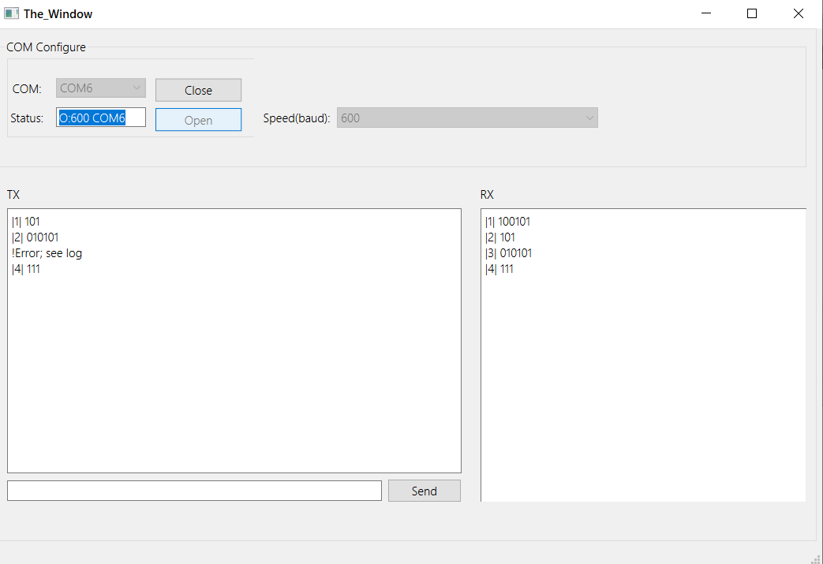

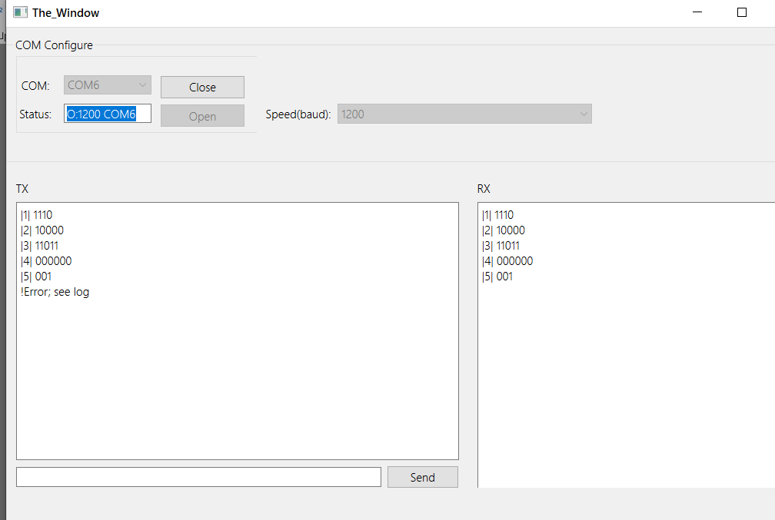

4. Заключение

В данной лабораторной работе была наглядно реализована работа пакетной передачи (COM-порты, эмулируются при помощи программы на ПЭВМ) и алгоритма бит-стаффинга, который служит для распознания начала и конца передаваемого пакета (вставка неинформационных битов в поток данных).

